**Attendance Recorder Lab Report**

**Tayyib Ul Hassan: 369648**

**Faras Siddique**

**Link to Github Repository**

https://github.com/tayyibgondal/attendance_recorder/tree/main/laravel-version

**Introduction**

The Attendance Recorder lab project aimed to create a robust web-based system for managing and recording attendance for students in a course. The system utilized PHP as the primary programming language along with a MySQL database to store student, teacher, course, enrollment, and attendance-related information.

**Functionalities**

**User Authentication**

* The system implemented user authentication for both students and teachers.

**Student Dashboard**

* Upon successful login, students were redirected to a dashboard displaying their attendance details.
* The dashboard presented the student's name, email, previous attendances, and the percentage of attendance in each subject.

**Teacher Dashboard**

* Teachers, upon login, accessed a dashboard showcasing the courses they were teaching.
* Functionalities included taking attendance for enrolled students in respective courses and viewing past attendance records.

**Attendance Recording**

* The system allowed teachers to mark students as 'present' or 'absent' for a particular session.
* PHP functions were used to process the submitted attendance data and insert/update records in the database accordingly.

**Usage of Laravel**

**Framework Choice**

* The Attendance Recorder system has been revamped using the Laravel framework, leveraging its robust features and efficient development ecosystem.

**MVC Architecture**

* Laravel follows the Model-View-Controller (MVC) architectural pattern, allowing for a structured and organized codebase. The system utilizes this architecture to separate business logic, presentation, and data handling.

**Eloquent ORM**

* The Eloquent ORM provided by Laravel simplifies database interactions by utilizing expressive syntax to perform various database operations. Models in Laravel represent database tables, enabling smooth querying and manipulation of data.

**Blade Templating Engine**

* Laravel's Blade templating engine facilitates the creation of reusable and modular views. Views are rendered using Blade, allowing for the inclusion of PHP code within HTML markup, enhancing the system's front-end flexibility.

**Division of Work**

**Tayyib Ul Hassan**: Implemented teacher dashboard, mark attendance functionality, as well as the view attendance functionality for teachers. Designed the database schema.

**Faras Siddique**: Realized the database schema. Implemented student dashboard, and login functionality.

**Database Design**

Tables

1. **Student**: Stores student details such as ID, name, email, and password.
2. **Teacher**: Holds information about teachers, including ID, name, email, and password.
3. **Course**: Contains course details such as ID, name, and teacher ID.
4. **Enrollments**: Manages the enrollment of students in courses.
5. **ClassAttendance**: Records attendance with student ID, teacher ID, course ID, start time, end time, and attendance status.

**Conclusion**

The Attendance Recorder lab project successfully implemented a functional web-based system for attendance management. Leveraging PHP and MySQL, the system provided authentication, dashboards for students and teachers, and robust attendance recording functionalities. The utilization of PHP functions for database interactions and data processing ensured efficient handling and manipulation of attendance-related information.

**Screenshots**

* 1. Login

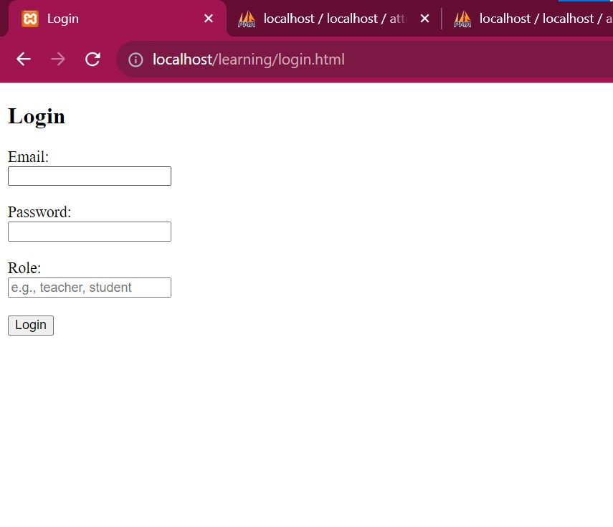

* 1. Teacher Dashboard

* 1. Teacher’s Previous Sessions

* 1. Teacher Updating Attendance of a Particular Session

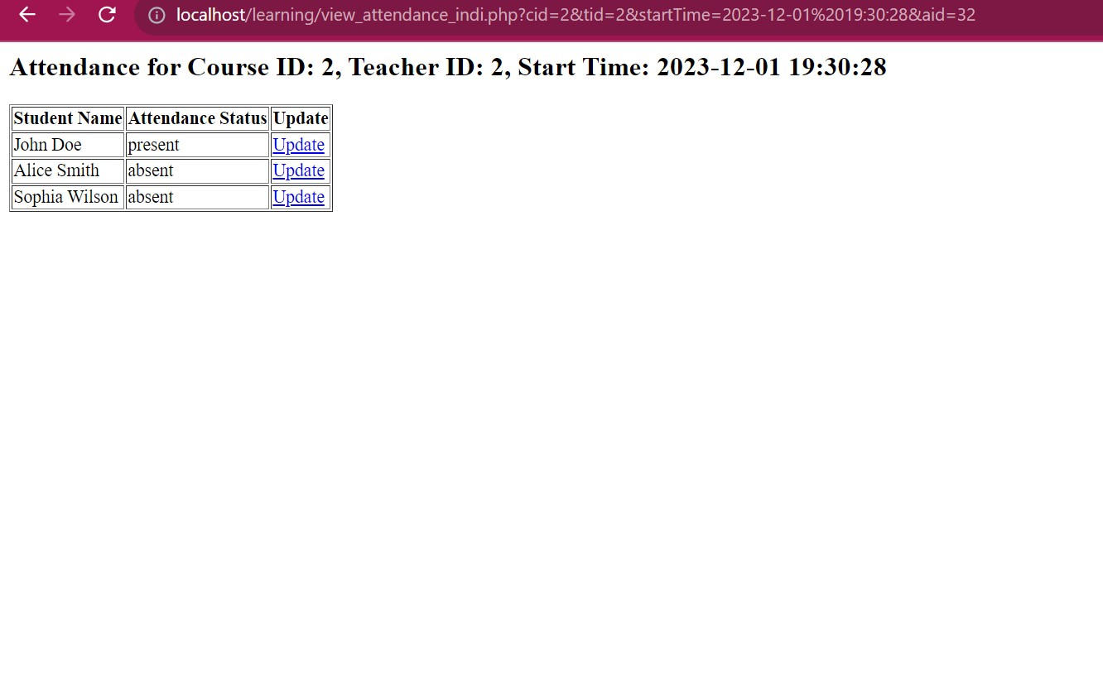

* 1. Update status form for teachers

* 1. Take attendance for teachers

* 1. Student dashboard

